The Use of Institutional Repositories
Its Acceptance, Maturity and Impact on the Book

The development of institutional repositories (IR’s) has been a recent one. IR’s were started by the University of Southampton (UK) in late 2000 when the University released a software package called E-Prints. Since that time, the establishment of institutional repositories has gained momentum. Factors such as the decreasing costs of online storage and the increase of broadband and gigabit networking technologies have contributed to IR’s growth in numbers and current popularity. The research is aimed answering several questions: 1) To what extent are IR’s as a method for communicating scientific and scholarly information, accepted? This question is examined through the lens of the Gartner Hype Curve. 2) How mature is the institutional repository as a technology when using the product lifecycle (Sigmoid Curve) and diffusion of innovation theory as measures? 3) What is the evidence (if any) that institutional repositories are impacting the role of the book?

Keywords: Institutional Repositories, Gartner Hype Curve, E-books, Product Life Cycle, Diffusion of
Innovation Theory

Introduction

Generally speaking institutional repositories (IR’s) can be described as virtual spaces created by post-secondary and other research institutions with which to make scholarly and other information/publications available on the internet. Early roots of institutional repositories can be found in the establishment of the National Digital Library of Theses and Dissertations that was launched in 1996 (Networked Digital Library of Theses and Dissertations 2010). However, the Networked Digital Library of Theses and Dissertations was limited in scope since it only accommodated theses and dissertations. The subject-based repositories, such as ArXiv (http://arxiv.org/) and REPEC (http://www.repec.org/) that became popular during the 1990s can also be regarded as early precedents for institutional repositories (Genoni 2004). Institutional repositories as we know them today really took off in 2000 when the University of Southampton (UK) released a software package called E-Prints. E-Prints was designed to accommodate journal articles and reports primarily, but could also accommodate electronic theses and dissertations. Packages that were developed subsequently, like DSpace and Fedora have similar functionality. Since 2000, the establishment of institutional repositories has gained momentum. Factors, such as the decreasing costs of online storage and the increase of broadband and gigabit networking technologies, have contributed to the growth in numbers and current popularity of IR’s.

Several options can be identified when looking on the Internet for places to store digital objects/files. These options include institutional repositories, digital libraries, digital object repositories and digital collections. It appears that there is no clear-cut distinction to be made among these. However since the focus is on institutional repositories, it is sensible to indicate what distinguishes institutional repositories from the other options. As part of its “Digital Repositories and Preservation Programme” pages, the Joint Information Systems Committee (2009) characterizes institutional repositories with the following requirements:

• the owner, content creator or third-party deposits content in a repository;
• metadata are managed along with the content within the architecture of the repository;
• a minimum set of services are offered (such as search and access control);
• IR’s are actively managed, well supported and sustainable;
• even IR’s that don't support open access (most do), must enhance access to the digital resources being accommodated;
• the metadata in institutional repositories are available for harvesting;
• IR’s might provide services, such as preservation of digital resources, data sharing and/or help with corporate records management.

Currently no self-respecting university or institution of higher learning will be caught without one. However, it appears that institutional repositories have not quite met the high expectations that were voiced as they grew in popularity. For example Prosser (2003), like others (Jones 2007 and Rumsey 2006), expected institutional repositories to change the landscape of scholarly communication by making the scholarly journal superfluous.

Research Questions

While institutional repositories have been part of the scholarly communication landscape for more than a decade, there are still many unanswered questions relating to their usefulness, acceptance and role in scholarly communication that need to be investigated. This study represents an attempt to answer some of the related questions. More specifically, the goal of this investigation is to look at institutional repositories from various angles, making use of established models, to answer the following questions:

a) To what extent are institutional repositories, as a method for communicating scientific and scholarly information, accepted?
b) How mature is the institutional repository as a technology?
c) What evidence is brought to light that institutional repositories are affecting the role of the book?

Questions a) and b) relate to the market penetration and productivity of IR’s. Phrased differently one could ask: how many/what percentage of postsecondary institutions makes use of IR’s and how well are their IR’s populated? Question c) relates to a lesser known use of IR’s: IR’s are capable of accommodating books. A question that may be asked in this respect is whether book production (of e-books) is being affected by the number of books published in IR’s?

Methodology

In answering question a), about the acceptance of institutional repositories, an attempt is made to track the progress of IR’s on the Gartner Hype Cycle as shown in figure 1. This tool is named after the Gartner Group that designed it in the 1990s in an effort to follow the typical evolution of new technologies from introduction to maturation. In later years the label of the horizontal axis was changed from “maturity” to "time" and the vertical axis was changed from “visibility” to "expectation" (Gartner Incorporated 2012).

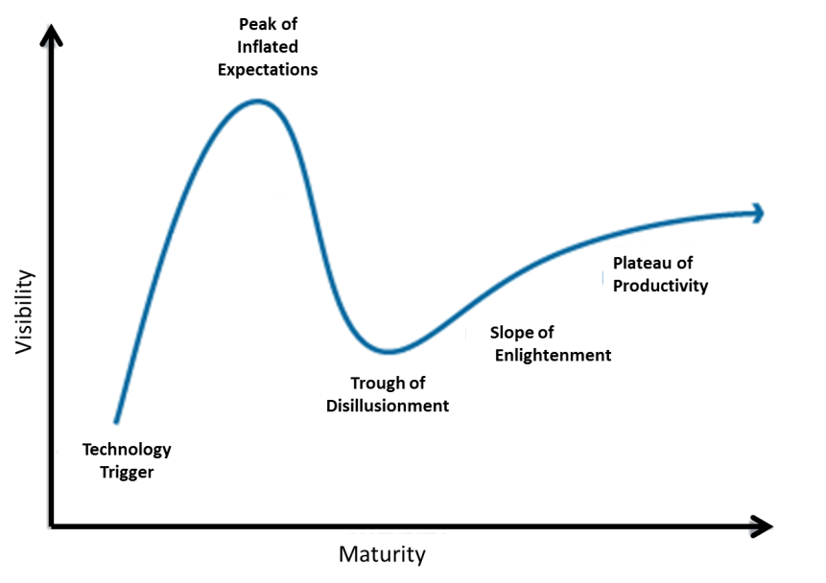

Figure 1: Gartner Hype Cycle

The question of the maturity of institutional repositories (question b), is answered by applying the Product Life Cycle (also called the Sigmoid Curve) and the Diffusion of Innovation Theory to the numbers of institutional repositories established during the past 10 years or so. The Product Life Cycle provides a way by which a product can be followed through four phases as illustrated in Figure 2. In his book The Empty Raincoat, Handy (1995) provides some pointers on how this model could be used.

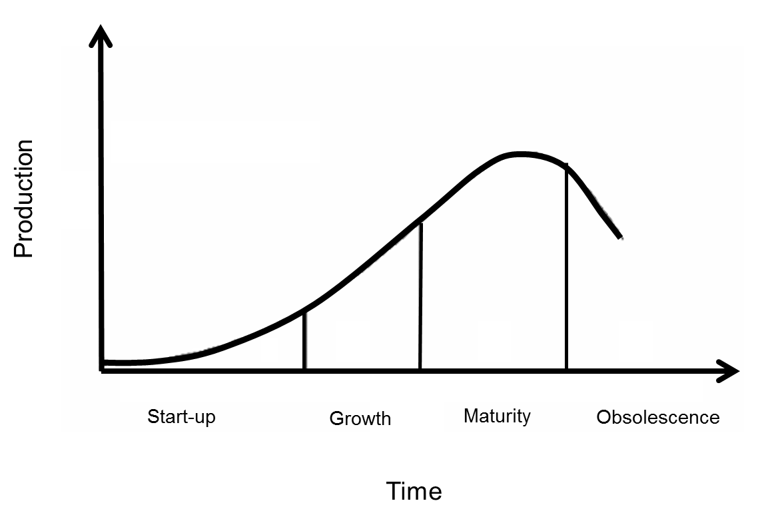

Figure 2: Product Life Cycle

The Diffusion of Innovation Theory attempts to categorize individuals by their ability to adopt new innovations. Figure 3 shows the five categories ranging from innovators to laggards and also indicates the percentage of individuals who might fall into these categories. This theory is presented here in a somewhat simplistic way. The influence of opinion leaders, change agents, and change aids (Clarke 1999), are all aspects of this theory but are ignored for the purposes of the study.

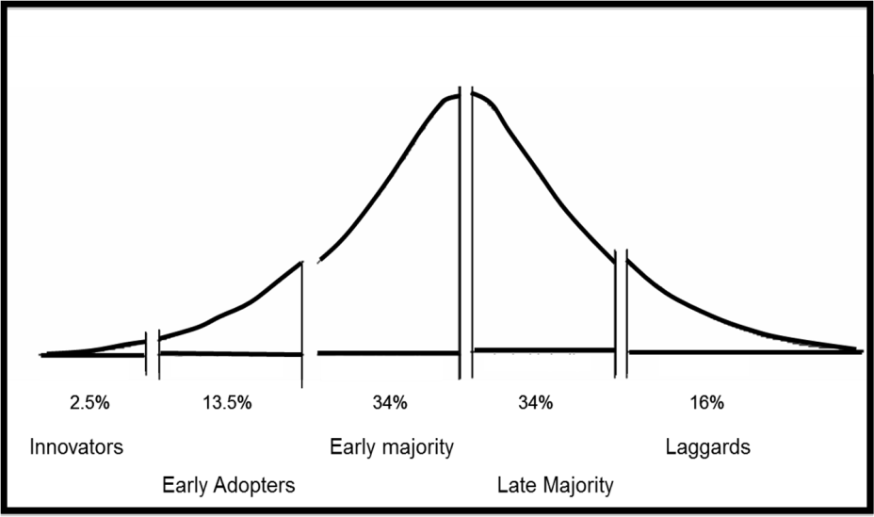

Figure 3: Diffusion of Innovation Theory

Answering the third question, question c), about the impact of institutional repositories on the e-book, proved to be more challenging. Since no specific model or methodology was available to help answer this question, anecdotal evidence found in the scholarly and trade literature and information found on webpages of institutional repositories was used.

The Evidence

The three questions are dealt with individually, making use of the methodologies set out and described in the previous section.

Hype of Institutional Repositories

The Gartner Group themselves tracked institutional repositories on the Hype Cycle and indicated/predicted where they thought it would be on the Hype Cycle in 2004. At the time, they called it E-Learning Repositories and projected that institutional repositories had already passed the "peak of inflated expectations". Gartner also estimated that IR’s would take approximately 2 - 5 years to reach maturity. This projection/estimation is presented as a graph in Figure 4 (Gartner Incorporated 2004).

It is argued that approximation of the future of IR’s as provided by Gartner was realized since it appears that nothing unforeseen has happened to the implementation and use of institutional repositories. The evidence is the (more or less) linear growth shown in Figure 6 (Number of articles on institutional repositories as found on Google Scholar by year of publication), Figure 7 (Growth of Institutional Repositories reported by OpenDOAR) and Figure 8 (Growth in Number of Repositories and Documents in BASE 2004 – 2012). Had there been little or no growth, erratic growth, or a year after year doubling of the numbers, validity of the estimation would have been in doubt.

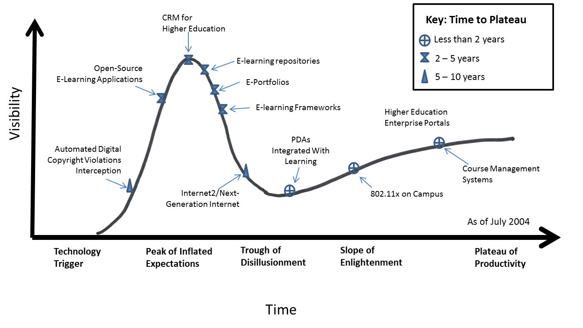

Figure 4: Gartner Hype Cycle of post-secondary education technologies

One could argue that if IR’s were just hype, a flash in the pan, this hype about institutional repositories would be reflected in the number of scholarly articles published on the subject of IR’s. Had it been the case, a bell curve spanning a short period of time would be indicative of such hype. The number of articles published in scholarly literature as reflected by Google Scholar was investigated to determine if the interest was waning or growing. The result is reflected in graph one which shows sustained growth and interest in the topic of IR’s.

If the number of articles on institutional repositories is taken as a measure of hype, it appears that the hype is still ongoing because the number consistently increased over a 10-year period, except for a slight leveling off during 2008-2009.

Figure: 5 Number of articles on institutional repositories as found on Google Scholar by year of publication

It is also clear that more use has been found for institutional repositories as the technology became more established. The range of material that might be accommodated by an institutional repository includes according to Tedd (2009):
• Pre-prints of papers
• Post-prints of papers
• Doctoral theses
• Masters dissertations
• Research reports
• Book chapters
• Conference papers
• Teaching materials
• Databanks of ‘raw’ data
• Multimedia objects

A case can be made that technical reports, newsletters, committee reports, statistical reports, guest lectures, surveys and papers in support of grant applications also be included (Genoni 2004). It would be safe to say that institutional repositories have reached the plateau of productivity. This statement is based on this evidence and the expertise of the Gartner group in tracking similar technologies and the fact that institutional repositories are currently three years past their most pessimistic estimate of five years to maturity.

Maturity of Institutional Repositories

Although there was initially a lot of hype around IR’s, there are several valid reasons for an institution to want to have one (Rumsey 2006): they are well suited to the management of digital objects and for the preservation of research results/reports. Also some funding bodies require that research reports be deposited in an open access repository. Moreover, IR’s can be used for institutional branding and increased visibility.

The growth in institutional repositories, in terms of both the number of repositories and content, suggests that IR’s as a phenomenon is maturing fast. If not already a mature technology it is well into the growth phase of the Product Life cycle. In order to make such a statement, one must look at the numbers of institutional repositories as well as the number items they contain. Such numbers were obtained from the Directory of Open Access Repositories (2012) as shown in Figure 6.

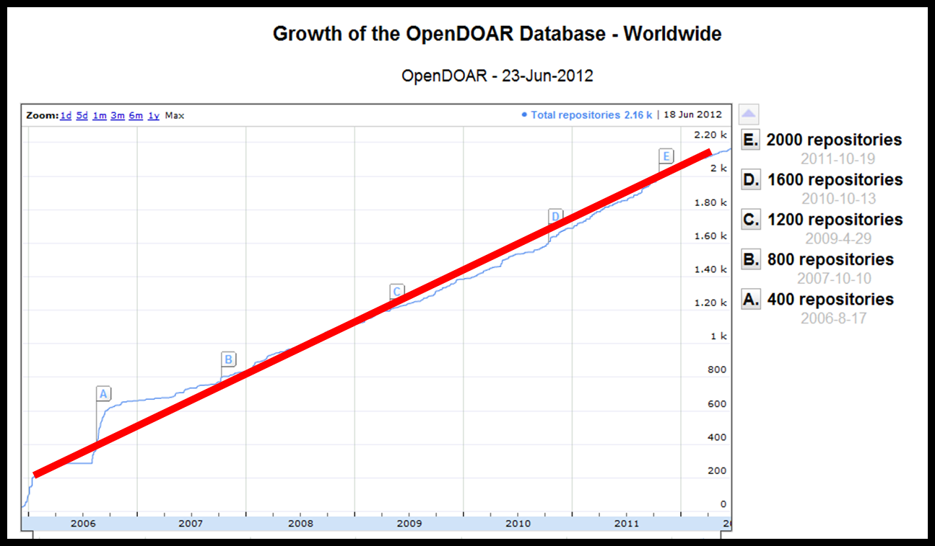

Figure 6: Growth of Institutional Repositories reported by OpenDOAR

Another source for numbers indicating the growth of repositories and of the volume of items contained in them is BASE (Bielefeld Academic Search Engine http://www.base-search.net). BASE claims that it is “one of the world's most voluminous search engines especially for academic open access web resources” (BASE - Bielefeld Academic Search Engine | About BASE 2011). Comparing the numbers in Figure 7, (BASE - Bielefeld Academic Search Engine | Statistics 2011) which indicate some 2,400 institutional repositories and around 32 million items/documents, with those in Figure 6, the numbers appear to be consistent. Moreover, both graphs show that the number of records have doubled from almost 16 million items to more than 32 million in little more than three years. An interesting number to mention at this point, to provide some kind of scale comparison is the estimated total number of academic articles in existence. Jinha (2010) estimated that this number surpassed the 50 million mark in 2009. One should hasten to add that institutional repositories accommodate many other formats apart from academic/journal articles.

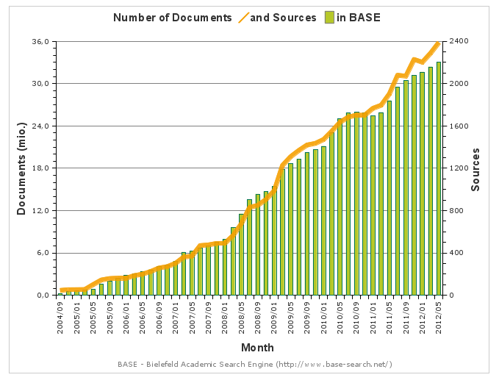

Figure 7: Growth in Number of Repositories and Documents in BASE 2004 - 2012

The charts also indicate a similar growth pattern. Since the growth of IR’s has not apparently tapered off, it can be argued that maturity has not yet been reached but that repositories are still in the growth phase in terms of the Product Life Cycle and part of the “early majority” phase with respect to the Diffusion of Innovation Theory. On the other hand, it can be argued that institutional repositories, as a product or service, have poor market penetration. It appears there are still many opportunities for growth. This argument can be based on the fact that there are around 20,745 institutions of higher learning worldwide (Cybermetrics Lab 2012) and both the directories have only about 2,200 repositories on record. These numbers suggest market penetration of around 10%.

Assuming the Diffusion of Innovation Theory holds true, the 10% market penetration suggests that institutional repositories are still in the “early adopters” phase. This researcher suggests that this is too pessimistic a view because many institutions of higher learning do not need an institutional repository. The count of 20,745 includes all types and sizes of institutions, also those that have no need/use for an institutional repository. In pursuing this line of thought one might argue that the target audience of institutional repositories is limited to research universities and institutes of higher education and research. In which case the pool of institutions that might be interested in institutional repositories and that would have a need/use for it can be reduced to about 2,500 institutions that operate at the Ph.D.-level (Academic Performance Research Laboratory 2012). If some 2200 institutions out of a pool of 2,500 already have repositories it would indicate that, in terms of the Diffusion of Technology Theory, institutional repositories are entering the “laggard” stage, see Figure 8.

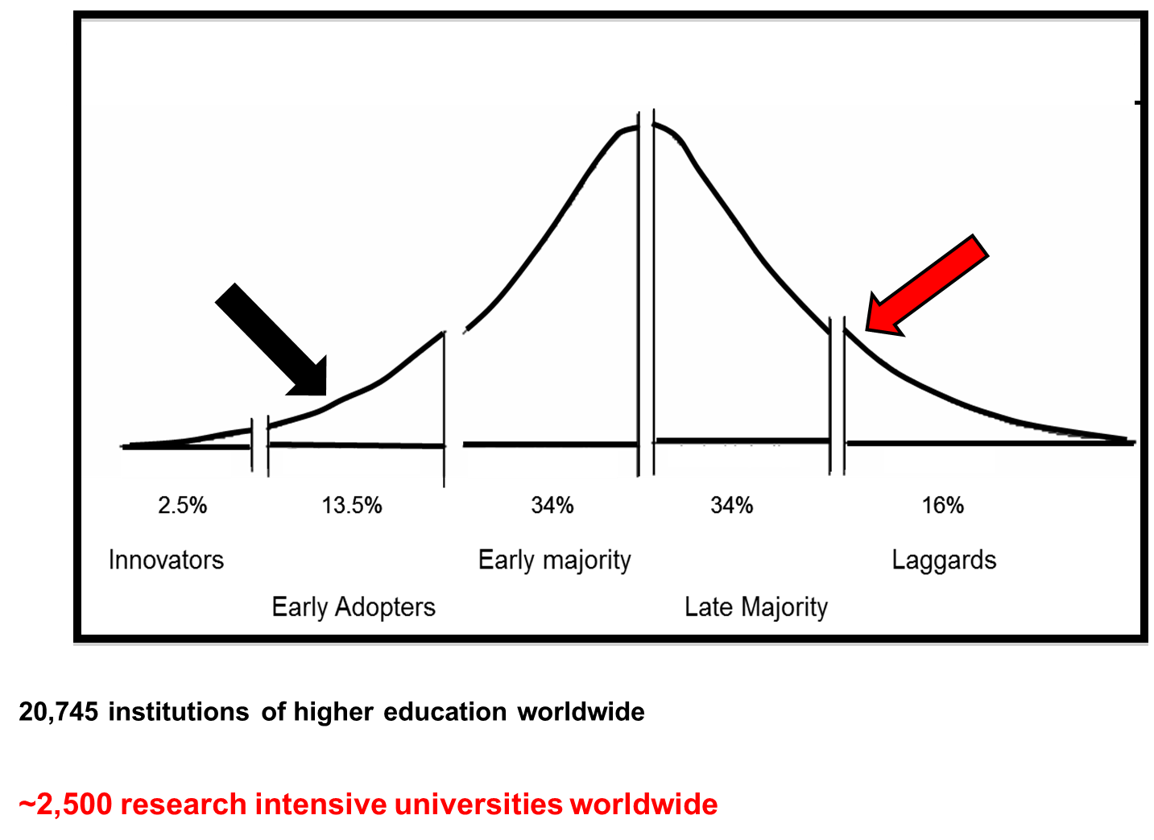

Figure 8: Maturity of Institutional Repositories in terms of the Diffusions of Technology Theory

Given the preceding data and arguments, there is evidence to support the idea that institutional repositories in terms of the Product Life Cycle find themselves in the maturity phase (see Figure 9).

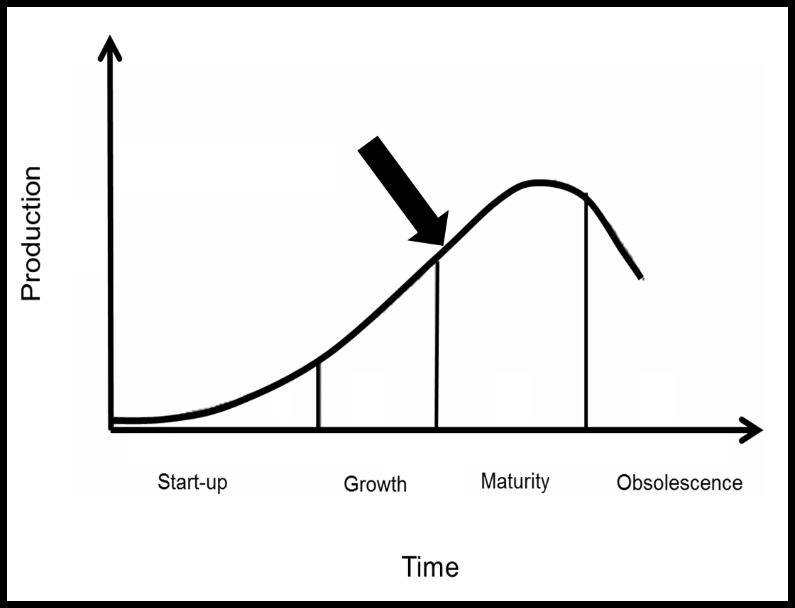

Figure 9: Maturity of Institutional Repositories in terms of the Product Life Cycle

The following two figures, dated June 2009 and 2012 (Directory of Open Access Repositories), respectively indicate that the number of repositories that collect books, chapters and sections have increased from 31% to 35% (501 to around 750).

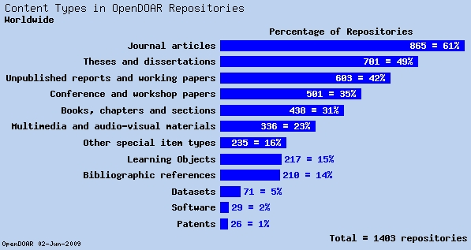
Figure 10: Content types in OpenDOAR Repositories in 2009

These numbers indicate that books and book chapters are not hugely popular since institutional repositories themselves grew by 54 % during the same three year period. On the other hand, it seems that the format distribution among new repositories that registered with the online directory has, generally speaking, presented the same mix of formats in its collections as those that were registered prior to 2009.

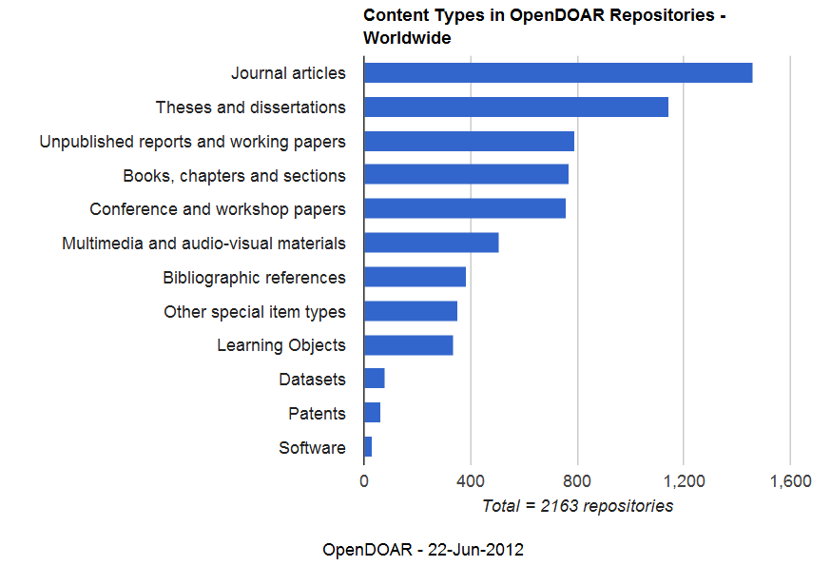

Figure 11: Content types in Open DOAR Repositories as in 2012

The e-book

In order for books to be accommodated in institutional repositories, they have to be in a digital format. Having arrived at that conclusion, it stands to reason that books within IR’s are either born digitally or have ended up in the digital realm after being born in the analog world and been subsequently digitized.

E-books maintained exclusivity until quite recently even though e-books have been around for a number of years. The current wider acceptance and popularity of e-books can be ascribed to (Joint Information Systems Committee 2012):

• the proliferation of e-books that are available online for free (for example project Gutenberg and the Google books project);
• the increase and growth in the number of titles that are available commercially through online dealers such as Amazon;
• the availability and affordability of dedicated hardware (E-readers);
• added readability because of the development of high-resolution screens for mobile devices;
• e-Books have an advantage in portability, customization (easy to change the font and its size or color) and added functionality, e.g. text-to-speech options.

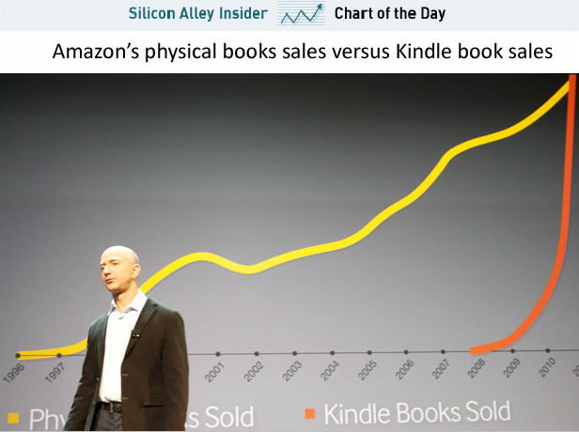

Figure 12: Rising popularity of e-books sold by Amazon.com (Jarow 2011)

The rising popularity of e-books (on the Kindle platform), as illustrated in Figure 12, is confirmed by a survey by the Pew Research Center (Rainie, Zickuhr, and Purcell 2012), see Figure 13.

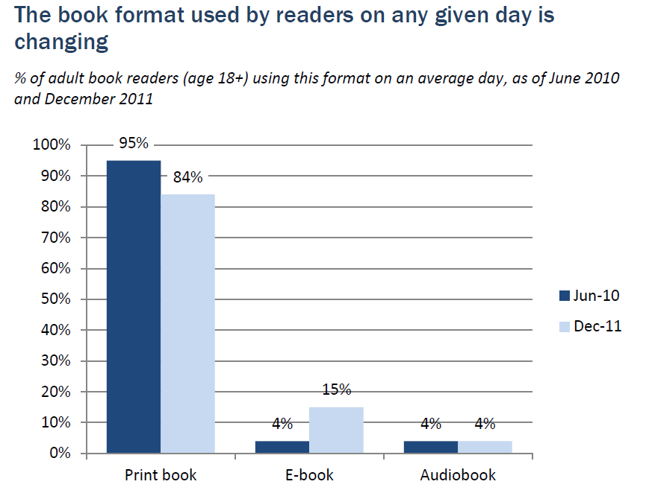

Figure 13: Increase of 10% in popularity in one year for the e-book

The last aspect that is examined concerning e-books is the performance of e-books in the marketplace. It appears that the e-book is currently overshadowed by the analog book. The paper book currently generates sales in the region of $5- $600 million per month, while the e-book generates about $100 million per month in sales (Wannabuy 2012). Figure 14 shows that there

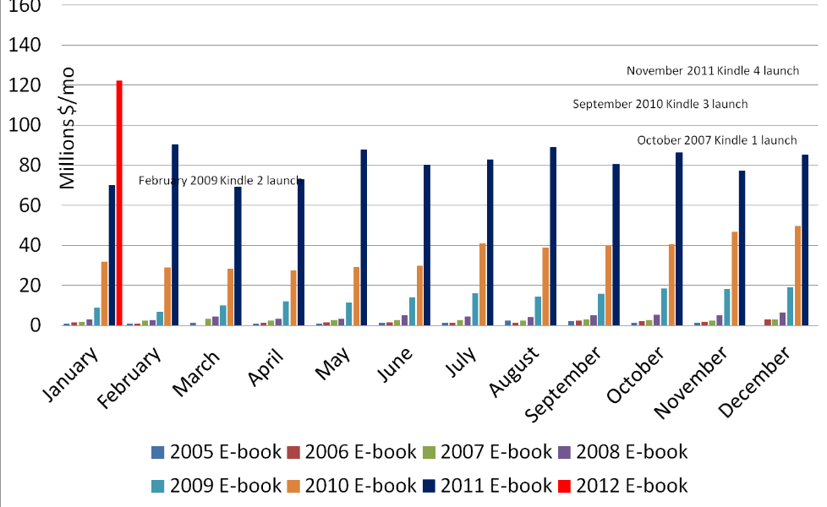

Figure 14: E-book sales versus analog book sales (Wannabuy 2012)

was considerable year on year growth in e-book sales during the last two years.
These sales translate into a market share of 27% for e-books that was reached in April 2012 (something that is not shown in Figure 14). It is also predicted that e-books will exceed a 50% market share towards the end of January 2013 (Wannabuy 2012).

Institutional Repositories affecting the E-Book

Generally speaking, the idea is to keep an open mind on what can be accommodated in an institutional repository. However, almost no mention is made of books being accommodated in IR`s, be it digitized (analog books) or e-books. This lack of attention to e-books in IR`s is confirmed by the absence of books on the list of materials compiled by Tedd (2009) (see earlier paragraph). Also, it is likely that the book chapters and book sections, like technical reports and conference proceedings are more like an anthology or a collection of papers and are treated as such. Even so one might suspect that these free downloads (of individual chapters or papers) would be in competition with a commercial counterpart and affect the sales of the commercial counterparts in some way. However no evidence was found to support this notion. In downloading documents from IR’s no sales figures are generated to be compared with the number of books sold, although the number of downloads can be counted. Anecdotal evidence suggests (that) the most popular items downloaded consist of items in different formats at each institutional repository. Usage statistics at some IR`s indicate that the most popular items might be proceedings of a conference while for others it might be a specific paper (Kelly 2011).

A study done by Amin (2007) showed that self-archiving of research papers in institutional repositories by faculty does impact journal subscriptions. This is contrary to popular opinion. Yet the question to grapple with here is whether the prevalence of e-books in institutional repositories impacts academic book sales. It might be significant that there is no mention of institutional repositories in a recent publication containing a collection of papers on e-books published by the American Library Association (No Shelf Required: E-books in Libraries 2011).
Jones (2007) states that since "books are substantial intellectual outputs, it is less likely that they will have been published in an open access environment…”. Nevertheless, today just about all theses and dissertations are available in open access institutional repositories almost as soon as the degree is conferred. This does mean that it is published (made widely available). Still the publishing of a thesis or dissertation by a commercial publisher is not as common as one might think. The following quotation from the Networked Digital Library of Theses and Dissertations (2010) website seems to support this claim: “In certain disciplines in the humanities it is often a requirement for young academics to publish monographs in order to get tenure at their institutions. Often they turn to their dissertations as a means to accomplish this. It is important that they understand that no academic press will publish a dissertation without considerable revision.”

Conclusions

Having considered the evidence discovered, the three research questions are addressed as follows:
- To what extent are institutional repositories, as a method for communicating scientific and scholarly information, accepted?
Examining the facts regarding the market penetration of IR`s (most Ph.D.-awarding institutions already have IR`s), the growth in the number of items deposited in IR`s (32 million items during the last 10 years) and the range of scholarly items (see the section on the hype of IR`s) the conclusion is that IR`s are largely accepted as vehicles for communicating scholarly information to a broad audience.

- How mature is the institutional repository as a technology?
Institutional repositories as a technology can be regarded as a mature technology. The conclusion is based on the Gartner Hype Cycle (indicating that IR`s have reached the plateau of productivity), the Product Life Cycle (indicating that IR`s have reached the mature stage) and on the steady growth in the number of articles on IR`s as reflected in Google Scholar search results.

- What evidence is brought to light that institutional repositories are affecting the role of the book?
The evidence provided in the section on the e-books shows that e-books have huge potential for growth and are becoming increasingly popular. However there no evidence was found indicating that books in IR`s have had any influence or impact on e-books or their production or distribution.

One aspect which prevents institutional repositories from becoming a threat to the e-book is the system of tenure and promotion in postsecondary institutions. Essentially items in an institutional repository remain unpublished. Since tenure and promotion greatly relies upon publishing scholarly papers and books in commercial publications, it is unlikely that faculty will use institutional repositories to distribute or make available their intellectual output as their only means of “publishing.” It should be noted that without being accepted by the formal/commercial publisher, items in an institutional repository remain gray literature. Also, it cannot be assumed that electronic theses and dissertations are the equivalents to e-books; therefore the hundreds of thousands of electronic theses and dissertations do not appear to have any significant impact on e-books.

If institutional repositories can be regarded as being synonymous with the Web this statement by Luey (2010) might be true: "Books will survive side by side with the Web because the format is well-suited to the reader’s purpose." Similarly IR`s are fulfilling a purpose in contributing to the dissemination of scholarly information. Therefore the recommendation is that any post-secondary institution that still finds itself without an IR, will do well to rectify this state of affairs since IR`s are not a hype or fad. They have developed into a permanent part of the scholarly communication landscape.

References

Academic Performance Research Laboratory. 2012. URAP - University Ranking by Academic Performance 2012 [cited July 29 2012]. Available from
http://www.urapcenter.org/2011/methodology.php?q=2.
Amin, Mayur. 2007. Article Repositories and Journal Subscription – Future Scenarios. Information Services & Use 27, no. 4:173-177.
BASE - Bielefeld Academic Search Engine | About BASE. 2012. 2011 [cited June 22 2012]. Available from http://www.base-search.net/about/en/index.php.
BASE - Bielefeld Academic Search Engine | Statistics. 2012. 2011 [cited June 22 2012]. Available from http://www.base-search.net/about/en/about_statistics.php?menu=2.
Clarke, R. Roger Clarke's Innovation Diffusion Theory 1999. [cited June 25 2012]. Available from http://www.rogerclarke.com/SOS/InnDiff.html.
Cybermetrics Lab. 2012. Ranking Web of World universities: Top World Ranking 2012 [cited July 29 2012]. Available from http://www.webometrics.info/top12000.asp.
Directory of Open Access Repositories. 2012. OpenDOAR Chart - Growth of the OpenDOAR Database - Worldwide 2012 [cited June 22 2012]. Available from http://www.opendoar.org/onechart.php?cID=&ctID=&rtID=&clID=&lID=
&potID=&rSoftWareName=&search=&groupby=r.rDateAdded&orderby
=&charttype=growth&width=600&height=350&caption=Growth%20of%
20the%20OpenDOAR%20Database%20-%20Worldwide.
Gartner Incorporated. 2005. Understanding Hype Cycles 2004 [cited April 22 2005]. Available from http://www.gartner.com/hc/asset50595.jsp.
———. 2012. Hype Cycle Research Methodology 2012 [cited 20 June 2012]. Available from
http://www.gartner.com/technology/research/methodologies/hype-cycle.jsp.
Genoni, Paul. 2004. "Content in Institutional Repositories: A Collection Management Issue." LibraryManagement 25, 6/7:300-306.
Handy, Charles B. 1995. The Empty Raincoat. London: Arrow Business.
Jarow, Jay. 2012. The Incredible Growth Of Amazon's Kindle Book Sales. Business Insider 2011 [cited June 25 2012]. Available from http://www.businessinsider.com/chart-of-the-day-amazonkindle-book-sales-2011-9.
Jinha, Arif. E. 2010. "Article 50 Million: An Estimate of the Number of Scholarly Articles in Existence."Learned Publishing 23, 3:258 - 263. doi: 10.1087/20100308.
Joint Information Systems Committee. Digital Repositories and Preservation Programme, Background: JISC 2009 [cited June 20 2012]. Available from
http://www.jisc.ac.uk/whatwedo/programmes/reppres/background.aspx.
———. 2012. JISC TechDis - Technology Matters - Beyond Text and Print - Working with Different Formats - e-Books. Joint Information Systems Committee (JISC) 2012 [cited June 15 2012]. Available from http://www.jisctechdis.ac.uk/techdis/ technologymatters/beyondtext/differentformats/ebooks.
Jones, Catherine. 2007. Institutional Repositories: Content and Culture in an Open Access
Environment. Oxford: Woodhead-Chandos.
Kelly, Brian. 2011. What Can We Learn From Download Statistics for Institutional Repositories? « UK Web Focus. In UK Web Focus: Reflections on the Web and Web 2.0. Bath.
Luey, Beth. 2010. Expanding the American mind : Books and the Popularization of Knowledge. Amherst : University of Massachusetts Press.
Networked Digital Library of Theses and Dissertations. 2012. History of the NDLTD — NDLTD, 2010-03-15 2010 [cited June 20 2012]. Available from http://www.ndltd.org/about/history.
No Shelf Required: E-books in Libraries. 2011. Chicago: American Library Association.
Prosser, David. 2003. "Institutional Repositories and Open Access: The Future of Scholarly
Communication." Information Services & Use 23, no. 2/3:167.
Rainie, Lee, Kathryn Zickuhr, and Kristen Purcell. 2012. The Rise of E-reading. Washington, D.C.: Pew Research Center.
Rumsey, Sally. 2006. "The Purpose of Institutional Repositories in UK Higher Education: A Repository Manager's View." International Journal of Information
Management, 26, 3:181-186. doi:10.1016/j.ijinfomgt.2006.01.002.
Tedd, Lucy. A. 2009. "Open Access Publishing and Institutional Repositories: An Overview." In Convention on Automation of Libraries in Education and Research. Pondicherry University, Pondicherry, India.: INFLIBNET Centre. [cited June 15 2012] Available from http://shodhganga.inflibnet.ac.in/dxml/handle/1944/1094
Wannabuy. 2012. "October 2011 E-book Sales." In E-book comments. Los Angeles. [cited 20 June 2012] Available from http://ebookcomments.blogspot.ca/

