How do they get there? Where do they go? An exploration of senior administrator hiring practices and roles in Canadian academic libraries.
Nicole Eva, Associate University Librarian, University of Lethbridge
Jasmine Hoover, Science and Scholarly Communications Librarian, Cape Breton University
Abstract
The process for hiring and terms of employment of University Librarians/Deans and Associate University Librarians/Associate Deans in Canada varies widely, as does the way in which academic library administrative units are organized. Using a survey method, we asked questions on whether it is most common for libraries to do external vs internal searches for these positions; the composition of the hiring committees; the qualifications of successful candidates; and the terms and conditions of their appointments, such as whether they are able to return to the faculty ranks when their mandates are over. A survey of Canadian university libraries tried to determine commonalities and differences in these hiring processes, as well as the administrative structures of these organizations. This is not a well-studied area, so we hope to contribute to the literature on this topic and aid any academic libraries going through reorganization or changes in administration.
Introduction
There is very little in the literature about the leadership teams and hiring processes in Canadian academic libraries. When looking for best practices from peers, information collected about the overall administrative structures and hiring practices of other university libraries across Canada is sparse. Clearly much variation exists given the diverse size and nature of institutions, but some commonalities may be found, and best practices gleaned from others. The authors had both investigated different aspects of these practices individually but thought that a survey might be the most expedient way of gathering some data from our peers across the country.
Literature review
There is research on desired qualities in academic library leadership (Fitsimmons, 2008 & Lo et al. 2020), key competencies of library leaders (Kim & Angakoon, 2016), and challenges faced by modern academic library leaders (Le, 2015). However little research has been done that provides insight into any commonalities, differences, or best practices across Canadian higher educational institutions when it comes to the organizational structure and hiring processes of top leadership in academic libraries. Are top leadership positions hired internally or externally? Are administrators on terms or permanent positions? Is this outlined in the collective agreement at the institution? Do they require an MLIS degree?
Studies have shown that despite many changes in position titles, and more research being done showing the benefits and examples of shared leadership models in libraries, library organization has remained hierarchical (Meier, 2016). In many academic institutions there is also disenfranchisement of librarians from decision making including the appointment and evaluation of senior library administrative positions (Revitt and Luyk, 2016).
The Changing Roles of Senior Administrators by DeLong, Garrison and Ryan (2012) focused on positions that report directly to the library director. They found that between 2007- 2012 the number of positions reporting to the director had not changed. Preliminary research being done by Hoover has shown that the number of library leadership positions (University Librarians and Assistant/Associate University Librarians) at university libraries across Canada have generally stayed the same over the last ten years (Hoover, n.p). This contrasts with the ballooning number of administrative level positions (Vice Presidents and Associate Vice Presidents) in higher education over the last several years (ANSUT, 2023). However, it could be that some top administrative positions in the library are new, non-librarian roles. Wilder outlines, from the 2015 ARL salary survey, that 40% of non-traditional new hires in libraries do not have library degrees (2018). The category ‘administration’ was part of this list. In a 2012 study from ARL, new library leadership positions emphasized various ‘other’ areas including academic affairs, HR, IT, financial director positions and marketing (DeLong et al, 2012) Similar findings were outlined in a Canadian study from 2015, where Sorensen and DeLong found that ‘other’ professional staff positions in the academic library grew 72% between 2003-2013 (2015). Their updated survey in 2020 demonstrated continued growth of ‘other’ professionals (Sorensen and DeLong, 2020). Sorensen and DeLong’s 2020 survey found that 13% of ‘other professionals’ were working in senior administrative positions in the library (2020). Wilder notes that the increased hiring of ‘non traditionals’ has had an impact on credentialing for the profession and could lower the profile of library education (2018).
In Canada, we have seen a few examples over the last several years when it comes to library leadership, particularly of heads of the library who are not librarians. There has also been new library leadership models demonstrated, including joint leadership of Information Technology and the Library as a Chief Information Officer (Brandon University), and an attempted loss of the University Librarian position altogether at Mount Allison, where it was proposed that the Dean of another school run the library (Mount Allison University). The head librarian role has often been combined with other leadership roles such as the archives, or other academic units such as privacy or writing centers, and several head librarians at large universities also have Vice Provost in their title, expanding their roles beyond the library.
Multiple articles on succession planning in libraries suggest that libraries do not establish appropriate succession plans or participate in succession planning activities on a regular basis (Goldman, 2023). Goldman found that libraries with more second level managers (Assistant/ Associate University Librarians) were engaged in succession planning activities more frequently (2023). Goldman asserts that many libraries rely on recruiting experienced managerial candidates from other libraries (2020).
Galbraith, Smith, and Walker (2012) found that 53% of study participants preferred to hire external candidates for the top library leadership positions; however, they had no preference between internal and external candidates for AUL’s or department heads. In practice, the same percentage (53%) of top librarian administrative positions were hired externally, while AUL and department heads are more often hired internally (Galbraith, Smith & Walker, 2012). A similar finding from Taylor and Lee (2014) found that half the respondents indicated they hire executive level library staff from outside the organization. They advocate for succession planning, which can save money and time, and lead to high quality candidates (both internal and external) for future leadership roles.
Hopper (2011) also discusses internal vs external hiring of library administrators. She outlines that in some cases the relationship between the preceding director of the library with administrators can result in internal or external hiring, and that often collective agreements can direct the necessity of conducting an external search. The majority of respondents in her study believed that a full-scale search is the ideal, no matter if internal or external candidates end up being hired to ensure a fair search (Hopper, 2011). DeLong et al (2012) found the same; the majority of survey respondents expected to recruit from outside the library but view internal candidates favorably. In contrast, Richard found that academia favors hiring outside candidates, which makes it less likely for academics to move from faculty to administrator roles within the same institution (Richards, 2016).
Unlike businesses where leadership often comes from programs that include leadership and management training, many librarians will serve as an interim leader at some point in their career, often without such training (Hoffman & Barker, 2022). This is a commonly seen occurrence in academic libraries as various leaves or retirements are often filled, in the short or long term, by existing librarians. This has proved often to be a great learning and confidence building experience for those interested in leadership positions but also was found to occasionally lead to higher workload and stress as well as damaged relationships (Hoffman & Barker, 2022). A survey by Irwin and deVries (2019) found that 79.5% of those filling interim Dean positions at their academic library were also performing their previous roles simultaneously. People put in interim positions often have little notice and can end up sitting in these positions longer than anticipated due to the slow nature of hiring in academia (Irwin & Devries, 2019).
Most Canadian academic librarians are unionized and are most often members of the faculty union at their institution (Harrington and Gerolami, 2014). Collective agreements in Canadian academic libraries often drive the hiring process; however, many have vague language around top library administrator positions, and separate university policies around hiring administration. Collective agreements can also hinder succession planning as Goldman found that the language often inhibits librarians from supervising staff members in other unions; this limits the potential supervisory experiences they may have before taking on administrative roles (2020).
Despite being the norm for other faculty, Ridley (2014) found that the practice of ‘stepping back into faculty ranks’ was almost unheard of in academic libraries. Senior administrative positions are seen as career milestones, with those attaining them having no intention of moving ‘backwards’. Some administrators felt unwelcome to return to the faculty ranks after being on ‘the other side’ (Goldman, 2020). Instead, library leaders often stay in the role, seek similar roles, or retire from the role. Ridley attributes this to librarians not having the same kind of academic career cycle that other faculty have. They also noted a lack of support, policy and procedure in moving back into the librarian role. Ridley noted that at the University of Guelph, the head librarian was a permanent role, unlike most academic libraries where leaders serve terms like the other Deans in the institution (2014). Ridley notes that even in cases where terms are the norm, there is often a lack of clear policy, procedure or expectations for a chief librarian to move back into the ranks. This often leads to chief librarians staying until they retire. Their suggestion is that librarians should have true faculty status, including chief librarians having appointments with term limits, that match other academic administrators (Ridley, 2014).
Olin and Millet (2015) outline the disparity between the number of females in the library profession, and those who are leaders. They also note that for a profession that has always been predominantly staffed by women, the ratio of male vs female leaders - while slowly shifting - has remained high. The gender breakdown in the profession as a whole from research cited is 80% Women and 20% Male (Olin & Millet, 2015). In 2012, De Long found that 50% of the leadership of members of the Canadian Association of Research Libraries were women. By 2018, the Association of Research Libraries survey (as cited in Bladek’s 2019 article) indicated that 59% of library leaders were women (Bladek, 2019). This demonstrates a continued gender imbalance when it comes to library leadership.
Mayeski and Sharrow (1982) wrote about problems with recruitment for library management, finding that many job advertisements had been reopened, demonstrating this difficulty recruiting. Ridley (2014) also mentioned difficulties with hiring associate chief librarians and managers (2014), due to lack of incentives to hire them. Ridley suggests a more supportive policy and reward structure that facilitates returning to the faculty rank might encourage more people to apply for administrative positions.
Data Collection
The study was reviewed for ethical acceptability and approved by the University of Alberta Human Participant Research Ethics Office (Pro00142405) on June 12, 2024. A survey was developed using the Qualtrics survey software and distributed via the Canadian AUL Listserv by the authors on July 4, 2024. Respondents were asked to identify their institution in order to de-duplicate to one response per institution, ensure adequate representation across the country, and to assign a size category; once this was completed, the institution names were removed from the data set. Only one institution had two complete answers submitted, and those responses were combined into one response (no contradictions were observed). A few institutions were contacted individually to ensure geographical and size representation. In the end, 28 completed responses were received, with a good representation of academic libraries from across Canada and from institutions of all sizes. Incomplete data on organizational structures and/or collective agreement language on certain topics, particularly when not well-reported in the survey, was supplemented by researching the university’s public web sites. Result reports and an excel sheet of results were downloaded from Qualtrics to conduct all analysis; some visualizations were obtained from Qualtrics, and others were created in Excel.
Results & Discussion
Our survey aimed to capture a ‘state of the nation’ in terms of hiring practices and portfolios for Canadian academic library leadership. No value judgment questions were asked; rather, our aim was to find both common and disparate practices, in order to establish a benchmark for libraries looking for examples.
Of the 28 unique institutions responding, sixteen (58%) said that the head of their library had the title University Librarian (UL), a few of those having University Librarian combined with another title (such as the Dean of another school/faculty or Vice-Provost). Eight hold the title of Dean (some with additional titles such as Archives or Cultural Resources), and three Chief (again, some with additional language, such as Vice-Provost). Additional answers have been withheld due to confidentiality. As a result, as with our survey, the term University Librarian (UL) will be referred to throughout this paper to indicate the library's head.

Figure 1
Head Librarian Titles
Title | Additional Titles | Number of Institutions
University Librarian | University Librarian +  Dean of another unit  Vice Provost  Dean of Libraries | 16
Dean | Dean +  Cultural Resources  Archives  University Librarian | 8
Chief | Chief +  Vice Provost | 3
Other |  | 1

Libraries at large institutions model other faculties or colleges as the university librarian sits at the same level as other Deans. They also most often report to the same person (VP academic or Provost) as other Deans at an institution (Hoover, 2022). However, as demonstrated in the survey, there are often variations or combinations of titles that make library heads somewhat unique.

Previous literature (Moran, et.al, 2009; Olin & Millet, 2015; Bladek, 2019), demonstrates an unbalanced dynamic where gender distribution among library leadership is not proportional to the percentage of men and women working in academic libraries, with males having a higher share of leadership positions. However, the gender breakdown for University Librarians (ULs) in our survey was very close to the Canadian average of 72% female librarians working in libraries (Canadian Association of University Teachers, 2017), with 75% of our respondents indicating the head of their library was female.
Figure 2
Gender Breakdown of University Librarians
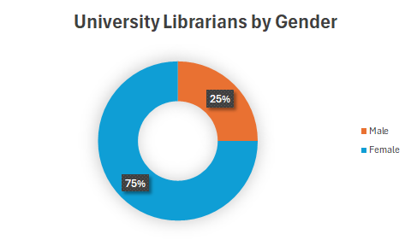

Only three of the ULs did not hold a Masters of Library Science (MLIS) or equivalent. Of the three, two had other Masters degrees (one in an information related field), and one had a PhD in an unrelated field. Although there has been much discussion around the MLIS as a requirement and as a terminal degree for librarians, most ULs still have an MLIS degree. Many universities have MLIS or equivalent requirement mentioned in policy or collective agreements in Canada as a requirement of librarian hires, though those policies are often not applicable to administrative hires. A quick scan of recent advertisements for University Librarian job ads in Canada indicates that most do ask for an MLIS. The current search at the University of Saskatchewan under “Experience and Education” outlines that an “ALA-accredited Master of Library and Information Science degree or international equivalent is required” (University of Saskatchewan, 2024). Of note, the Canadian Association of University Teachers does not stipulate that the criteria should include a MLIS in their Guidelines for the Appointment and Review of Library Administrators Outside the Bargaining Unit (Canadian Association of University Teachers, 2023).
Interestingly, all of the libraries indicating their UL did not hold an MLIS were on the smaller end of the scale in terms of range of sizes of responding institutions. It may be due to economies of scale, the fact that two of the three roles are combined with another role; or it could also be due to the inability to attract MLIS-credentialed ULs to smaller institutions. This may also reflect Mayeski & Sharrow (1982) and Ridley’s (2014) findings that there is not a large pool of qualified applicants with leadership experience. This could be a further area to investigate.
The number of Associate University Librarians (AULs) at responding institutions ranges from zero to more than five. This is somewhat dependent on size, as can be seen in Figures 4 & 5; from the responses received, more than five AULs (29%) was the most common response, followed by three (21%), and then zero (18%), with four each responding with one or two, and one responding that they have four AULs.

Figure 3

Number of AULs at Respondent’s Institutions
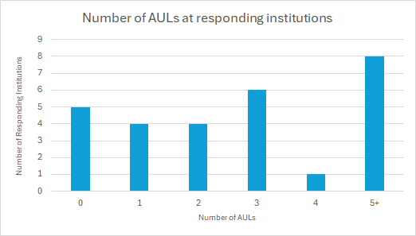

On average, across all respondents, Canadian academic libraries had an average of 2.6 AULs. This broke down as shown in figures 4 and 5 below.

Figure 4

Range and average number of AULs by institution size

Broad size band | Number of Respondents | Range | Average
<5,000 | 3 | 0-1 | 0.33
5,000-10,000 | 6 | 0-1 | 0.5
10,000-20,000 | 5 | 2-3 | 2.4
20,000-30,000 | 3 | 2-4 | 3
30,000-40,000 | 4 | 3-5+ | 4.5
40,000-50,000 | 5 | 3-5+ | 4.2
50,000+ | 2 | 5+ | 5
Totals | 28 | 0-5+ | 2.64

Figure 5

Number of AULs by size bands
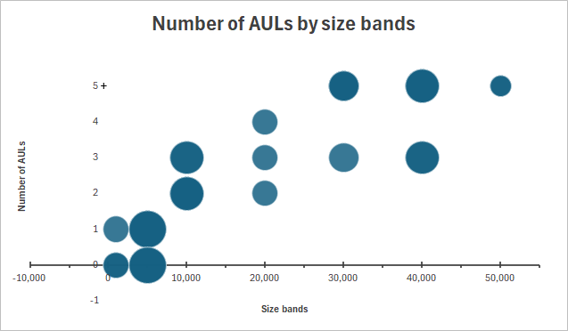

It appears that at some point the library is large enough that more leadership positions are needed, and this seems to vary from institution to institution. Based on a scan of libraries across Canada, the tipping point for introducing AULs is around 7,000 students. Larger libraries have as many as 6 AULs, sometimes more depending on how many branches the institution has.
The portfolios of library administrators vary widely, especially as the size of the institution dictates the number of leadership positions therein. However, generally speaking the UL role most often involves leadership of the library, representation on university-wide administrative groups such as provost leadership teams and is responsible for strategic direction. They are often also in charge of the library’s operations budget. The AUL roles are more internally focused and often involve managing specific libraries within a larger system, and/or specific areas of library service such as collections, systems, teaching and learning, access, or research. Having a leadership team of AULs is unique to libraries as academic units. When asked about roles and duties of AULs in our survey, they generally oversee various functional areas of the library. In contrast, Associate Deans in other faculties cover duties related to the whole school or faculty, and chairs oversee departments.

Figure 6 demonstrates the terms most often used to describe the AUL role.

Figure 6. Terms in AUL Portfolios

Most respondents indicated that the hiring process for ULs is set out in a policy that dictates how searches for senior administrators are conducted. These policies are separate from the Collective Agreement or Faculty Handbook. However, this still results in very different search committee structures between institutions, ranging from those which are very defined as to membership, to those in which the membership is decided entirely by the provost. Some variations include having an external (to the university) member; student members; with and without librarians; with and without staff members; and even some without any library members at all. For the most part, however, the committee structure is well-defined and includes librarian members.

In contrast, hiring processes for AULs varies widely. For those institutions at which the AUL is out of scope, their hiring processes are sometimes dictated by the senior administrator policy. Overall, though, the process for AULs ranged again from interviewing with only the UL, to a range of library staff (both academic and non-academic) and externals being on the hiring committee. It seems that the ‘rules’ for hiring AULs are nowhere near as set in stone as they are for UL hires; it would be interesting to see if this correlates with Associate Dean positions in other academic units.

The vast majority (89%) of institutions post for UL vacancies externally, or simultaneously externally and internally (see Figure 7). However, our results show that only 43% of current ULs at responding institutions were hired externally, with 35% hiring internal candidates hired and 22% answering ‘other’ to this question. The ‘other’ answers ranged from the candidate being internal to the university but not the library, and the rest described currently having an internal interim UL and expecting to hire externally.

Figure 7

University Librarian Job Posting and Hires

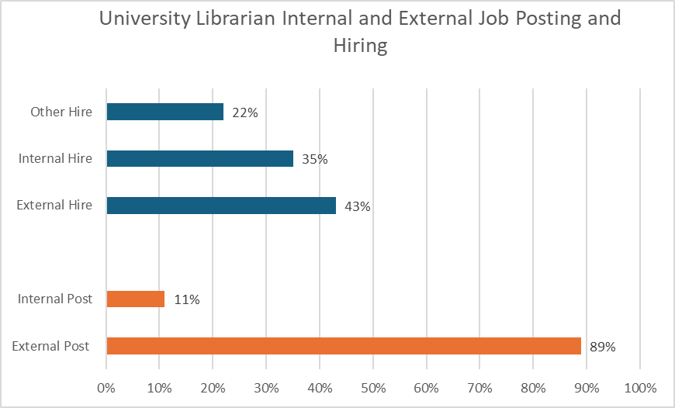

Our findings correlate with Galbraith, Smith & Walker’s findings from their 2012 survey of 34 American institutions where the majority of respondents believe it is imperative to post externally. The majority of respondents also felt that they would prefer to hire leaders with a fresh perspective and ideas from another library.
For AULs, 62% responded that AUL positions were posted externally, with only 22% reporting that they hired an external AUL. (See Figure 8). Five institutions with more than one AUL had a mix of both internal and external hires. In the additional comments, we found that acting AULs are internal the majority of time.

Figure 8

Associate University Librarian Job Postings and Hires

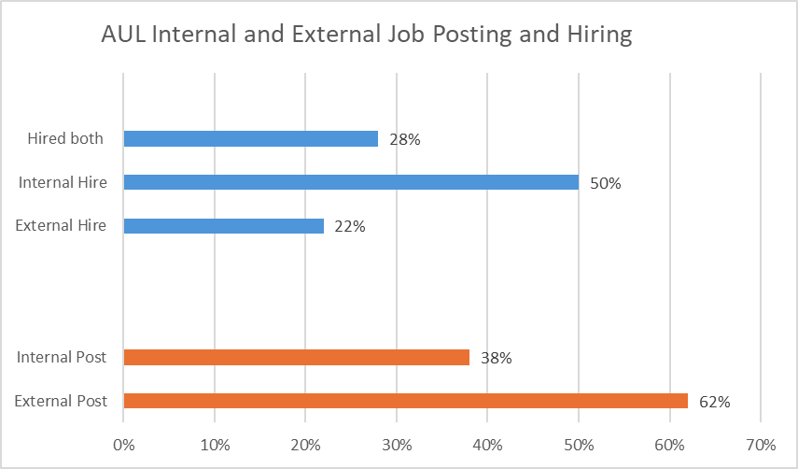

University librarians are often hired on a term - the majority of respondents were 5-year terms, often with the chance to renew (see Figures 9 & 10). This demonstrates that although libraries are distinctive entities within the university structure, the head of the library position is similar in process to other academic Deans who often serve on 5-year terms and can then return to the faculty ranks. Fewer libraries who answered the survey had 3-year terms, and some were permanent. Additional answers were between six and ten years.

Figure 9

University Librarian Term Length
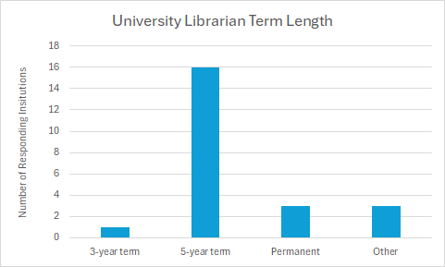

These terms are almost always renewable, with only one respondent indicating that otherwise; the majority of answers (43%) indicated that the number of renewable terms for ULs was unlimited. Next most common was one renewal (22%), with 9% indicating it could be renewed twice, and five additional comments indicating either that it’s unclear or seems to vary historically.

Figure 10

University Librarian Term Renewals
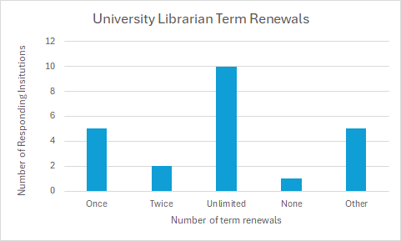

AULs also commonly serve 5-year terms, with 69% of respondents whose libraries have AULs serving 5-year terms. Only one respondent indicated a 3-year term, one indicated a variable term, and the rest indicated that their terms were permanent. As with ULs, the majority (47%) of respondents indicated that the AUL terms had unlimited renewals, with one respondent indicating there were no renewals, four (24%) responding that they were only renewable once, one each indicating two and three renewals, and a few saying that it was unclear or variable. Of note, some comments mentioned that even when renewals are unlimited, occasionally AULs are encouraged to move on after a couple of terms.

Figure 11

AUL Term Length
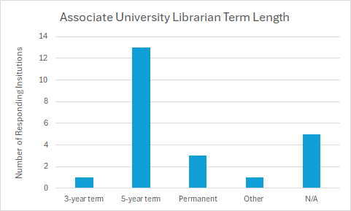

Figure 12

AUL Renewals
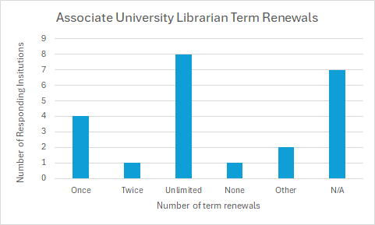

70% of ULs and 83% of AULs can return to the ranks when their terms are complete, but in practice most either move on or retire. However, it is certainly not unheard of, with several respondents having experienced a mix. The literature agrees that while it is rare, it is possible in most cases. Ridley (2014) describes a lack of process to follow to step back into the ranks, as well as the career progression of librarians as reasons for this potential reluctance for librarians to return to the ranks like their other academic counterparts. This may be an interesting topic to investigate with individual interviews in the future. However, it was also noted that acting or interim ULs usually do return to their former positions.

The final survey question asked for a link to the organizational charts, which bore out much of what the survey results indicated, with the number of library administrators and their respective portfolios matching what respondents told us.
Conclusion
Academic libraries remain their own unique entity within universities and show variation between institutions in the titles, roles and hiring practices of senior administrators. Positive findings included a gender balance of University Librarians which mirrors that of the general library demographic, and the presence of MLIS degrees amongst them. While it seems that University Librarians are more uniform in terms of hiring processes and term lengths/limits between institutions, and more in line with heads of other academic units within institutions, there is much less consistency in how Associate University Librarians are hired. ULs most often have standardized search committees, are advertised externally, and have fixed terms with limits on renewals, the results around AULs are far murkier.
While it is understandable that the portfolios and number of AULs would vary from institution to institution, based on size, other variations make less sense. From search committee composition to term lengths and renewals, there is little consistency between institutions. Anecdotally, this may be in line with how Associate Deans are hired as well; perhaps it is a function of the Associate role to be less defined. One commonality among both ULs and AULs, which would seem consistent with other academic administrators, is their ability to return to the ranks, despite it rarely occurring. However, it would seem from this broad picture of the Canadian academic library landscape that libraries would benefit from more uniformity, particularly regarding the hiring practices for AULs. The ambiguity between and even within institutions can be confusing, so more consistency in terms of how positions are posted, whether the searches are done internally or externally, and particularly the composition of the search committee, would be of benefit not only for institutions but for librarians interested in library leadership.

Limitations and Future Research
One limitation to this research is the small sample size, given the diverse sizes of the respondents. While it gives us a promising idea of the broad range of organizations, it is difficult to draw many firm conclusions based on the small sample for each institution's size.
The results from this study give us a broad idea of how Canadian academic libraries organize their leadership teams, but it is just the tip of the iceberg for more research to be conducted. It would be interesting to delve deeper into some of the individual questions, including deeper discussions on the implication of library leaders lacking MLIS degrees, the background and qualities that make a successful library leader, developing internal opportunities to develop leadership skills for succession planning, and the most successful organizational structure and portfolio makeup of academic libraries, based on size. It is hoped that these results will spark some interest in furthering the depth of research on Canadian library leadership.

References
ANSUT. (2023). A culture of entitlement: An overview of administrative compensation at eight Nova Scotia universities 2011/12- 2020/21. (p. 53). Association of Nova Scotia University Teachers. https://www.ansut.ca/wp-content/uploads/2023/03/Culture-of-Entitlement-Report-2012-2021_FINAL-REVISED.pdf
Bladek, M. (2019). From women-staffed to women-led: Gender and leadership in academic libraries, 1974-2018. Journal of Library Administration, 59(5), 512–531. https://doi.org/10.1080/01930826.2019.1616970
Canadian Association of University Teachers. (2017). Librarians in Canada’s universities and colleges. CAUT Education Review. https://www.caut.ca/resources/almanac/3- academic-staff
Canadian Association of University Teachers. (2023). Guidelines for the appointment and review of library administrators outside the bargaining unit. https://www.caut.ca/about-us/caut-policy/lists/caut-policy-statements/caut- guidelines-for-the-appointment-and-review-of-university-chief-librarians-and- other-library-administrators-outside-the-bargaining-unit
De Long, K. (2012). True north: Journeys in leadership of women library directors in Canadian academic libraries. Simmons College. https://www.proquest.com/docview/1704414478?pq- origsite=gscholar&fromopenview=true&sourcetype=Dissertations%20&%20Theses
DeLong, K., Garrison, J., & Ryan, M. (2012). Changing role of senior administrators (330; SPEC). Association of Research Libraries. https://publications.arl.org/Changing-Role-of-Senior-Administrators-SPEC-Kit-331/
Fitsimmons, G. N. (2008). Academic library directors in the eyes of hiring administrators: A comparison of the attributes, qualifications, and competencies desired by chief academic officers with those recommended by academic library directors. In E. D. Garten, D. E. Williams, J. M. Nyce, & J. Golden (Eds.), Advances in Library Administration and Organization (Vol. 26, pp. 265–315). Emerald Group Publishing Limited. https://doi.org/10.1016/S0732-0671(08)00206-X
Galbraith, Q., Smith, S. D., & Walker, B. (2012). A case for succession planning. Library Management, 33(4/5), 221–240. https://doi.org/10.1108/01435121211242272
Goldman, C. (2020). Structure, culture, and agency: Examining succession planning in California State University (CSU) Libraries. Journal of Library Administration, 60(1), 1–21. https://doi.org/10.1080/01930826.2019.1671035
Goldman, C. (2023). Academic library succession planning in the Association of Research Libraries (ARL). Journal of Library Administration, 63(4), 519–553. https://doi.org/10.1080/01930826.2023.2201720
Harrington, M. R., & Gerolami, N. (2014). Highs and lows: An examination of academic librarians’ collective agreements. FIMS Presentations, 20. https://ir.lib.uwo.ca/fimspres/20?utm_source=ir.lib.uwo.ca%2Ffimspres%2F20&utm_medium=PDF&utm_campaign=PDFCoverPages
Hoffman, A., & Barker, A. (2022). The impact of the interim leadership experience on library middle managers. Journal of Library Administration, 62(7), 863–886. https://doi.org/10.1080/01930826.2022.2117952
Hoover, J. (2022). Dysfunction by (dis)organization: The academic library within university structure and organization. In Libraries as Dysfunctional Organizations and Workplaces (pp. 283-291). Routledge.
Hopper, R. E. (2011). Is the devil you know better than the devil you don’t know: Issues in academic library leadership recruitment. A Declaration of Interdependence. ACRL 15th National Conference, Philadelphia. https://alair.ala.org/server/api/core/bitstreams/690308ed-79fc-49b2-b202-b2dd33f5a8c8/content
Irwin, K., & deVries, S. (2019). Experiences of academic Librarians Serving as interim library leaders. College & Research Libraries, 80(2), 238–259. https://doi.org/10.5860/crl.80.2.238
Kim, J., & Angnakoon, P. (2016). Research using job advertisements: A methodological assessment. Library & Information Science Research, 38(4), 327–335. https://doi.org/10.1016/j.lisr.2016.11.006
Le, B. P. (2015). Academic library leadership in the digital age. Library Management, 36(4/5), 300–314. https://doi.org/10.1108/LM-07-2014-0083
Lo, P., Allard, B., Anghelescu, H. G. B., Xin, Y., Chiu, D. K. W., & Stark, A. J. (2020). Transformational leadership practice in the world’s leading academic libraries. Journal of Librarianship and Information Science, 52(4), 972–999. https://doi.org/10.1177/0961000619897991
Mayeski, J. K., & Sharrow, M. J. (1982). Recruitment of academic library managers: A Survey. Journal of Academic Librarianship, 8(3), 151–154.
Meier, J. J. (2016). The future of academic libraries: Conversations with today’s leaders about tomorrow. portal: Libraries & the Academy, 16(2), 263–288. https://doi.org/10.1353/pla.2016.0015
Moran, B. B., Leonard, E., & Zellers, J. (2009). Women administrators in academic libraries: Three decades of change. Library Trends, 58(2), 215–228. doi: https://doi.org/10.1353/lib.0.0088
Olin, J., & Millet, M. (2015). Gendered expectations for leadership in libraries. In the Library with the Lead Pipe. https://scholar.google.com/scholar_lookup?title=Gendered+expectations+for+leadership+in+libraries&author=J.+Olin&publication_year=2015&pages=1-8&inst=9846201079423970744
Revitt, E., & Luyk, S. (2016). Library councils and governance in Canadian university libraries: A critical review. Canadian Journal of Academic Librarianship, 1(1), 60-79. https://roam.macewan.ca/bitstreams/59d5b562-f851-444f-a0d5-25432ffb68ec/download
Richards, R. (2016). Succession planning in higher education: The influence of culture on the succession process in a community college [Mercer University]. https://ursa.mercer.edu/bitstream/handle/10898/11385/10103955_1.pdf?sequence=7
Ridley, M. (2014). Returning to the ranks: Towards an holistic career path in academic librarianship. Partnership: The Canadian Journal of Library and Information Practice and Research, 9(2). https://doi.org/10.21083/partnership.v9i2.3060
Sorensen, M., & DeLong, K. (2015). A changing profile of librarians in the Canadian Association of Research Libraries (CARL). In S. Schmehl Hines & M. Simons (Eds.), Advances in Library Administration and Organization (Vol. 34, pp. 263–275). Emerald Group Publishing Limited. https://doi.org/10.1108/S0732-067120150000034012
Sorensen, M., & DeLong, K. (2020). 8Rs Redux: 15 years later. Canadian Urban Libraries Council. https://culc.ca/wp-content/uploads/2022/02/CULC-8Rs-Redux-2020.pdf
Taylor, M. A., & Lee, E. (2014). Talent Management (344; SPEC Kits). Association of Research Libraries. https://publications.arl.org/Talent-Management-SPEC-Kit-344/9
University of Saskatchewan. (2024). Opportunity profile: University Librarian and Dean, University Library. University of Saskatchewan. https://leadership.usask.ca/documents/provost/searches-reviews/oppprof_usask_university-librarian_final.pdf
Wilder, S. (2018). Hiring and staffing trends in ARL Libraries. Research Library Issues, 295, 17–31. https://doi.org/10.29242/rli.295.3

