Copyright Permissions for Figures used in Masters Thesis

I have reproduced multiple figures in my MSc thesis. The following is a list of these figures, the rationale for their inclusion, and information regarding copyright:

Figure 2.1. Map of permafrost zones in the Northern Hemisphere, from Obu et al. (2019).
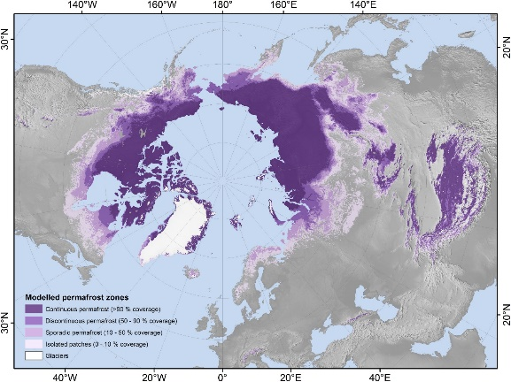

Rationale: this is the best model of permafrost distribution in the northern hemisphere and provides essential context for my thesis.

Copyright: Published in Earth Sci. Rev. (https://doi.org/10.1016/j.earscirev.2019.04.023) under a CC BY-NC-ND open access license.

Figure 2.2. Periglacial landforms indicative of permafrost presence.

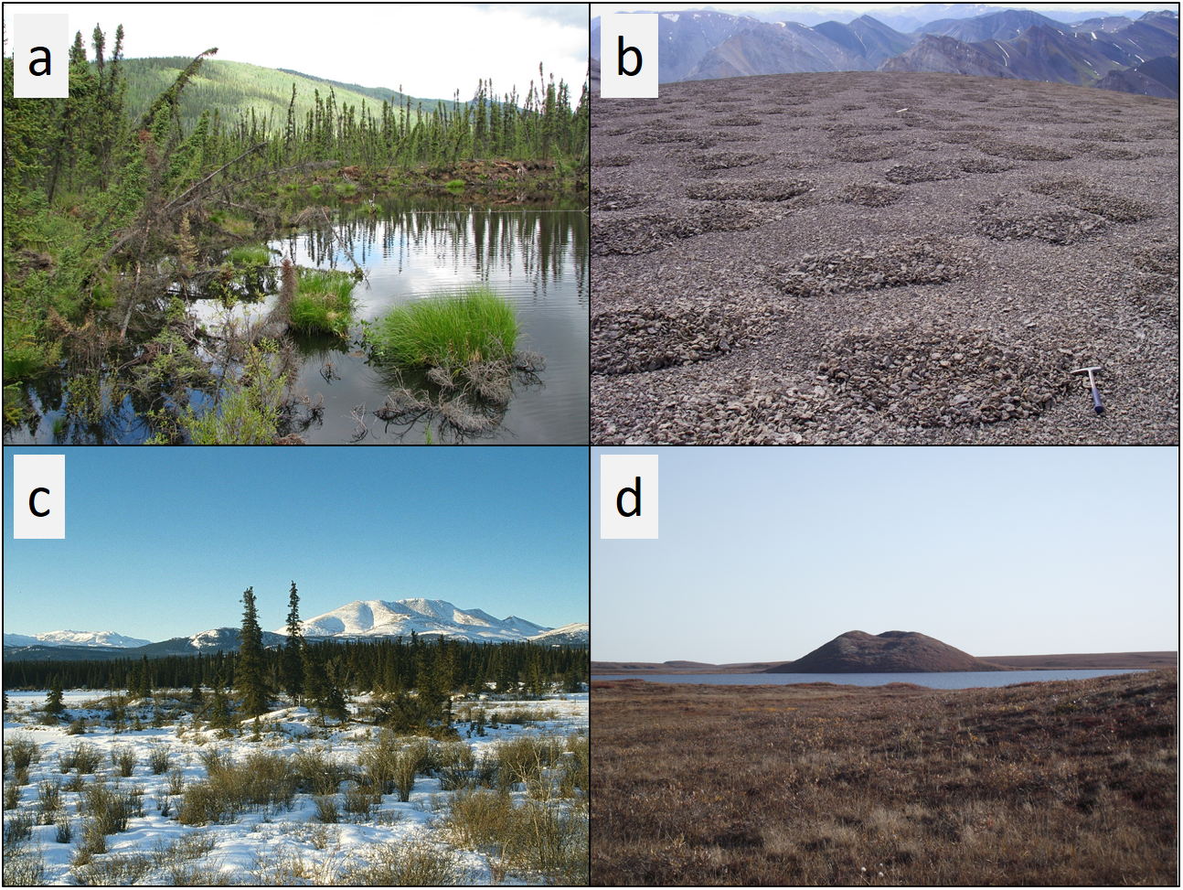

Rationale: It is important to show high-quality images of the landforms that I am studying.

Copyright: a-c published on the Yukon Landform Atlas by the Government of the Yukon under an Open Government License (https://open.yukon.ca/data/datasets/yukon-landform-atlas). d not published elsewhere; given by Hester Jiskoot, my supervisor with permission to publish in this thesis.

Figure 2.3. Three ground ice cryostructures.

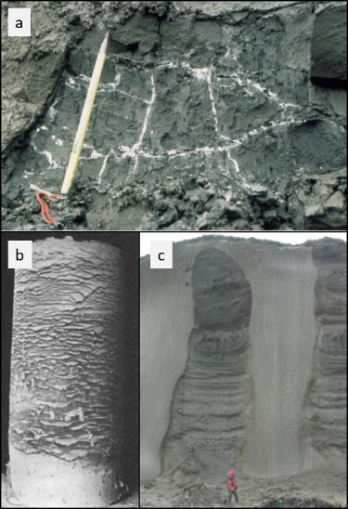

Rationale: It is important to show high-quality images of the cryostructures that I am studying.

Copyright: (a) published in The Periglacial Environment (2018) under CC by John Wiley & Sons. Fair dealing law allows the inclusion of this figure in my thesis. (b) published in 1929. Author (Stephen Taber) died in 1963. Hence, his works are in the public domain. (c) published in the Encyclopedia of Quaternary Science (2nd Ed.) (2013) under CC by Elsevier. Fair dealing law allows the inclusion of this figure in my thesis.

Figure 2.4. Ground Ice Map of Canada showing classified ground ice abundance by excess ice volume in the top 5 m of permafrost, from O'Neill et al. (2022).
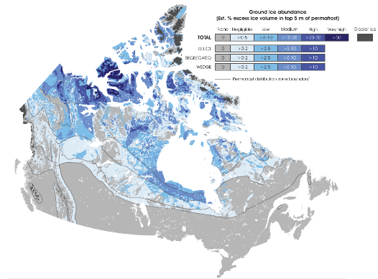

Rationale: this is the best model of ground ice distribution in Canada and provides essential context for my thesis.

Copyright: Published in The Cryosphere (https://doi.org/10.5194/tc-13-753-2019) under a CC BY open access license. Also published by Geological Survey of Canada (https://ostrnrcan-dostrncan.canada.ca/entities/publication/c63766ac-ac52-4f3d-bb4a-e184a42e5459) under an Open Government License

Figure 2.5. Various thermokarst landforms and their effects on surrounding environment and infrastructure.
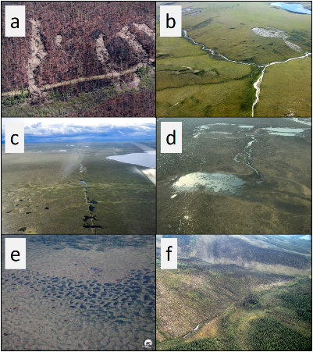

Rationale: It is important to show high-quality images of the landforms that I am studying.

Copyright: a, b and f are published on the Yukon Landform Atlas by the Government of the Yukon under an Open Government License (https://open.yukon.ca/data/datasets/yukon-landform-atlas). c and d are from Matt Nolan’s website (https://fairbanksfodar.com/) under copyright by Matt Nolan. Fair dealing law allows the inclusion of this figure in my thesis, and I received oral permission to include this figure in my thesis from the authors.

Figure 2.6. Map of wetland, lake and hillslope thermokarst landscape coverage across the circum-Arctic, from Olefeldt et al. (2016).

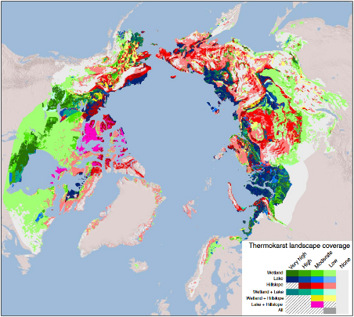

Rationale: this is the best model of thermokarst distribution in the northern hemisphere and provides essential context for my thesis.

Copyright: Published in Nature Communications (https://doi.org/10.1038/ncomms13043) under a CC BY open access license.

Figure 2.7. Permafrost hazard potential index in Representative Concentration Pathway 4.5 for 2041-2060, from Karjalainen et al. (2019).
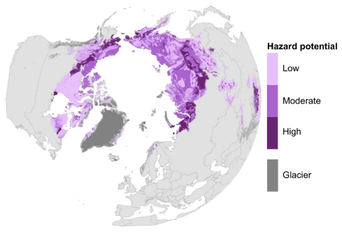

Rationale: this is the best model of permafrost hazard potential in the northern hemisphere and provides essential context for my thesis.

Copyright: Published in Scientific Data (https://doi.org/10.1038/sdata.2019.37) under a CC BY open access license.

Figure 3.3. Maximum Extent of Glacial Coverage in Northwest Canada from the late Pliocene to the late Pleistocene, from Duk-Rodkin and Barendregt (2011).
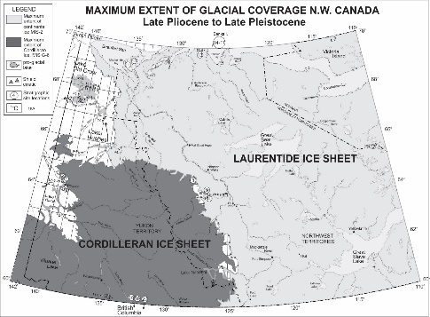

Rationale: The past glacial extents in Yukon shown in this map provide essential context for my thesis.

Copyright: Published in Dev. in Quat. Sci. (https://doi.org/10.1016/B978-0-444-53447-7.00032-5). Fair dealing law allows the inclusion of this figure in my thesis, and I received oral permission to include this figure in my thesis from the authors.

Figure 3.4. Permafrost presence probability map for southern Yukon, from Bonnaventure et al. (2012).
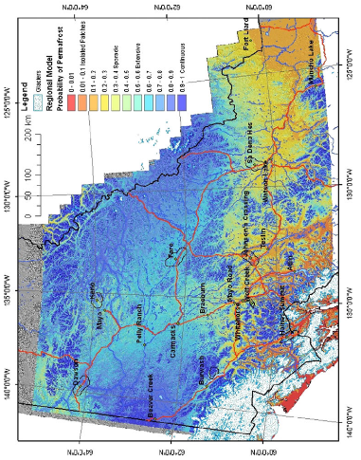

Rationale: this is the best map of permafrost distribution in Yukon, and provides essential context for my thesis. Additionally, the data used in this map are available from the Government of Yukon (https://service.yukon.ca/permafrost/), and were used in my thesis.

Copyright: Published in Permafrost and Periglacial Processes (https://doi.org/10.1002/ppp.1733). Fair dealing law allows the inclusion of this figure in my thesis.

Figure 3.7. The sign of topographic curvature based on Wysocki et al. (2000), after Richter (1962).

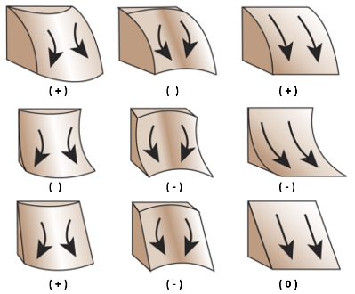

Rationale: this is an often-reproduced figure (many versions of it exist) which describes this aspect of topography. It is essential to include, as I use topographic curvature in my analysis.

Copyright: This was published in the Handbook of Soil Science (2000) under copyright by CRC Press. I adjusted the figure to suit my thesis needs. Fair dealing law allows the inclusion of this figure in my thesis.

