Supplementary Figure 1. Phylogenetic tree of the 4300 E. coli isolates with Salmonella as an outgroup; generated with IQ-TREE (v1.6.12).A) Colouration is by country of origin; data was from 16 different countries. B) Colouration is by by serotype (typed by ECTyper); the dataset had 162 unique O groups and 48 unique H types.
A) 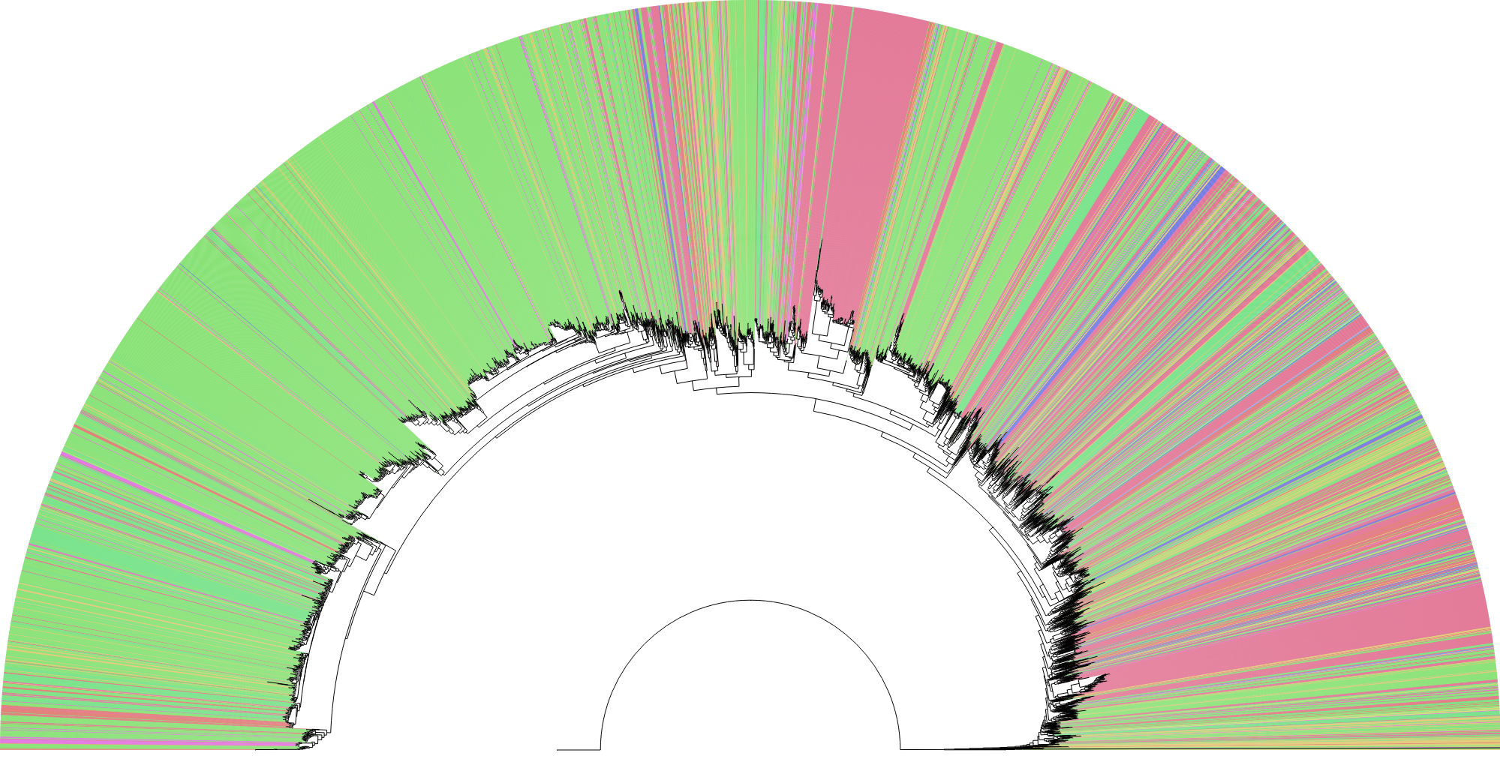 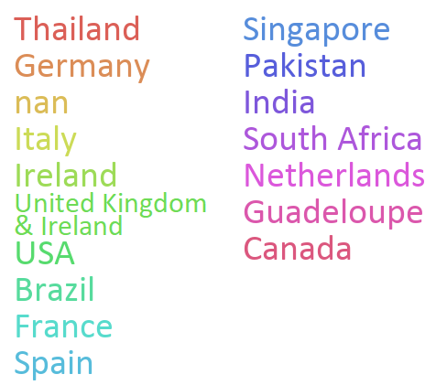
B) 